2021WEDDING PACKAGES
with keeping Social Distancing measures & restrictions requirements
This Rustic Décor & Rental Package starts at $2600.00

Includes: day of décor set up and next day dismantle

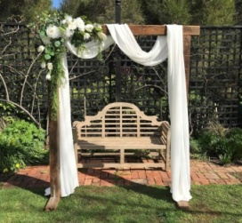
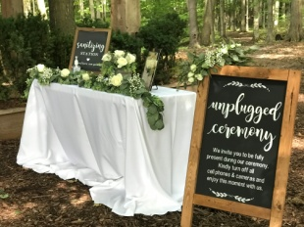
- Ceremony Décor $650
Arbor of your choice
Wood/Circle Blossom/Rustic doors
Flowing Drapes with Greenery and florals ( mixed faux & fresh)
Lanterns along the ceremony Isle
Unplugged ceremony side ( optional)
Sanitizing Station sign and includes managing social distance restriction seating set up

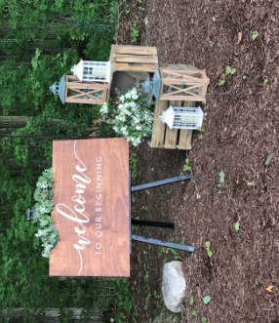
- Welcome Sign $ 350
Great your guest with a beautiful rustic sign
Includes Greenery /Easel and greenery
Crate and Lantern decor

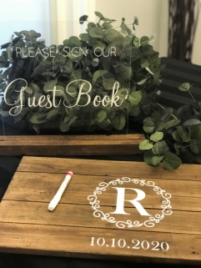
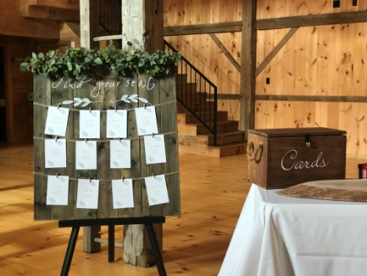
- Receiving Table Décor $350
Find your seat board
Easel and greenery
Card/busta box ( acrylic or wood)
Sign our guest book sign
Personalized wood guest book

- Sweet Heart/ Head Table Décor $750
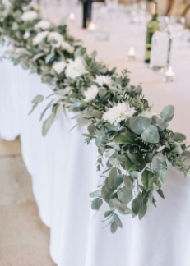
Greenery Runner base with fresh eucalyptus
candle décor along runner up to 18 ft
King and queen chairs available

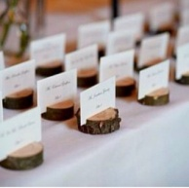
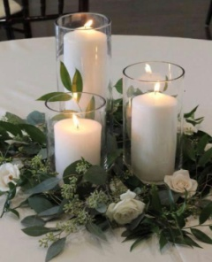
- Guest tables Décor $500 (includes up to 10 tables)
Greenery with Candle Décor
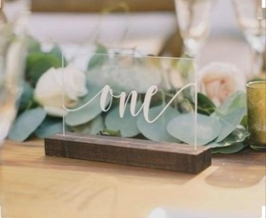
Wood slice base ( optional included)
Table Number ( wood or acrylic included)
Individual Name card holders

The following would be add on’s
- Same night dismantle is $300
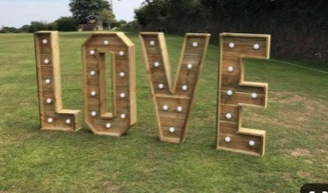
- Marquee LOVE $350
Instagram worthy area
Location suggestion near electrical outlets
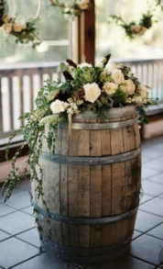
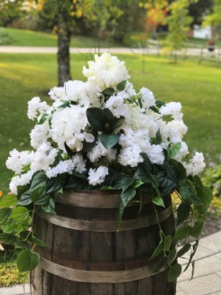
- BARREL $75 ea
with faux arrangements additional $50

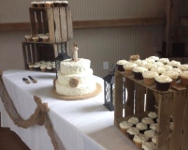
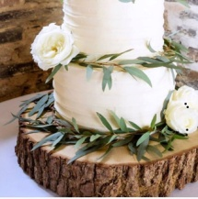
- Dessert & Cake Stn start at $150
Rustic Table / crates / bases
( cake not included)
Mr&Mrs Cake topper

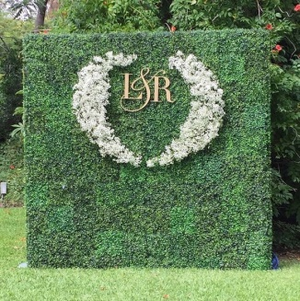
- Box wood Green wall backdrop $250
5 ft wide by 6ft high
Florals and initials are an additional $150

