2022 WEDDING PACKAGES

This Rustic Décor & Rental Package starts at $3000.00

Includes: day of décor set up and next day dismantle

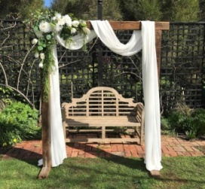
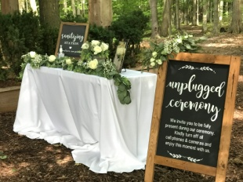
- Ceremony Décor
Arbor of your choice
Wood/ Cherry Blossom/Rustic doors
Flowing Drapes with Greenery and florals ( mixed faux & fresh)
Lanterns along the ceremony Isle
Pick a seat not a side sign or Unplugged sign

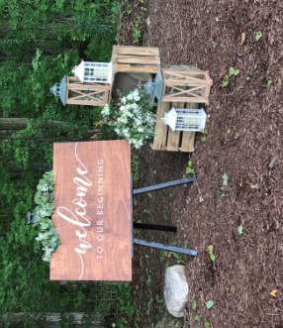
- Welcome Sign
Great your guest with a beautiful rustic sign
Includes Greenery /Easel and greenery
Crate and Lantern décor

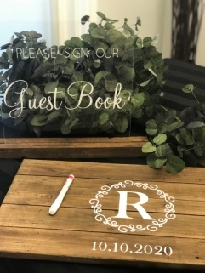
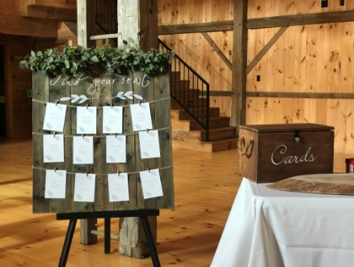
- Receiving Table Décor
Find your seat board
Easel and greenery
Card/busta box ( acrylic or wood)
Sign our guest book sign
Personalized wood guest book

- Sweet Heart/ Head Table Décor
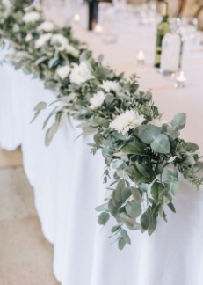
Greenery Runner base with fresh eucalyptus
candle décor along runner up to 18 ft
King and queen chairs available

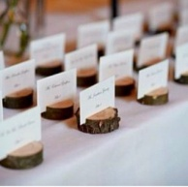
- Guest tables Décor (package includes up to 10 tables)
Greenery around Candle Décor / or Lantern
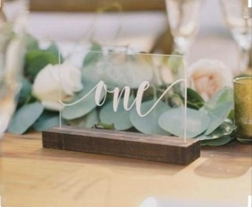
Wood slice base
Table Numbers (wood or acrylic included)
Individual Name card holders (name cards can be done for
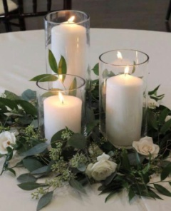
Additional fee)

